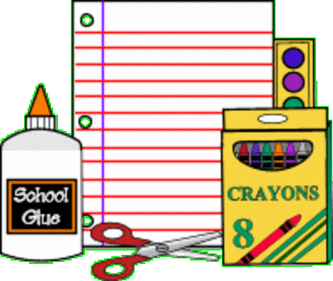
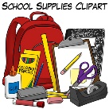
Materials List
Students must have their materials by Monday, 08-27-18.
Ms. Borges
6th Grade Mathematics

Binder
The following materials will be used to set up the student’s binder that will be used, daily.

- Three-ring Binder (2 inch with plastic insert cover)
- Dividers (5-Pack)
  - Label the tabs in the following order:
    - Warm Up
    - Classwork/Notes
    - Vocabulary
    - Home Learning
    - Intensive Math (Add this divider if the student is registered in Intensive Math)
- Notebook Paper (4 packs minimum. Will be used throughout the year)

Interactive Notebook
The following materials will be used to complete assignments in the student’s interactive notebook. These supplies are to be kept in the student’s bookbag. Assignments will be completed in class and/or at home.

- Composition notebook
- Individual Adhesive Divider Tabs (will be used for interactive notebook)
- Glue Stick (Jumbo – Sized)
- Colored Pencils and/or Crayons (No Markers)
- Scissors

Personal Supplies
The following materials are to be kept in the student’s bookbag. These are to be used daily and the student must always have these materials.

- # 2 Pencils (At least 2 packages. Will be used throughout the year)
- 2 red pens
- Personal headphones for computer station
- Mini Stapler
- Notebook 3-hole punch

